**COMP 202 Design Patterns**

**Spring 2024 18.04.2024**

|  |  |  |
| --- | --- | --- |
| **Name** | **Surname** | **Signature** |
|  |  |  |

1. (30 pts) Starbuzz Coffee has made a name for itself as the fastest growing coffee shop around. If you’ve seen one on your local corner, look across the street; you’ll see another one. Because they’ve grown so quickly, they’re scrambling to update their ordering systems to match their beverage offerings. When they first went into business. They designed their classes like this

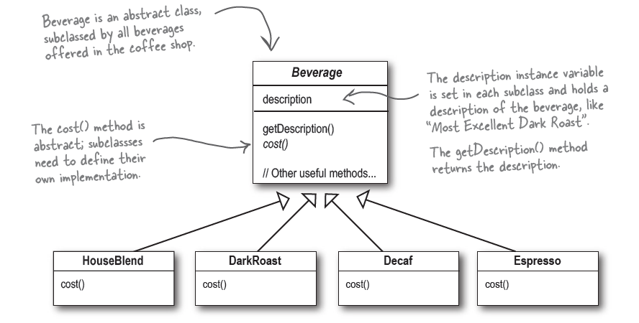

In addition to your coffee, you can also ask for several condiments like steamed milk, soy, and mocha (otherwise known as chocolate), and have it all topped off with whipped milk. Starbuzz charges a bit for each of these, so they really need to get them built into their order system.

In order to adapt the system of Starbuzz Coffee the given changes above:

1. (10 pts) Which design pattern should be utilized? Give a valid discussion for your suggestion. Explain pattern in your own words.
2. (20 pts) Draw UML Class Diagram based on your suggestion considering all improvement on the system.
3. (40 pts) In a robotics engineering course, you are guiding students to develop a software framework for constructing different types of robots with customizable components. The system should facilitate the creation of robots tailored to specific tasks, each with unique configurations of sensors, actuators, and processing units.
4. (20 pts) You should design a software framework that allows for the assembly of robots with varied configurations. Specifically give the name of the design pattern that you need to use here and draw UML class diagram for the given scenario. Explain how this pattern solve the given problem.
5. (20 pts) Consider how to structure the system to accommodate the construction of robots with diverse sensor types (e.g., cameras, lidars, proximity sensors), actuator mechanisms (e.g., motors, grippers), and processing units (e.g., microcontrollers, single-board computers). Each robot configuration should be customizable to include different combinations of sensors, actuators, and processing units based on the intended functionality. Based on given new specs above, which design pattern you should utilize to add this functionality and add new parts to UML Diagram in part(a).Explain how this addition bring the solution.
6. (30 pts) Given the class UML diagram below. Review the provided UML class diagram, and analyze the diagram and describe the types of relationships between each entity.

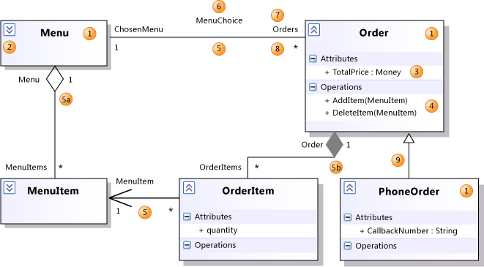

Give the **dependecy, composition and aggragetion relations** in the given UML Diagram.